CARE OF YOUR CLARSACH
You have joined The Clarsach Society and are now hiring one of our clarsachs. Here are some helpful notes on how to store and care for it, so that you can make the most of it and enjoy making it sing.

As a Branch member, you will receive information about courses and other events organised by your Branch, as well as about our Edinburgh International Harp Festival, and we hope to see you at both.
- YOUR HARP
  - The Instrument
- Your harp was made by [Insert Harpmaker here]
- The strings are made of gut / nylon / carbon
- Should a string break, please do not worry as this happens naturally; but it is your responsibility to replace it with one of the correct kind and gauge. The manufacturer can advise you on this HYPERLINK
- We have 3 simple videos to help you to identify and replace a string securely with the necessary
Knot. String names How to change a string Tying the string knot
  - Accessories
- As well as the instrument itself, you have been provided with a tuning key and a carrying case.
- PLAYING YOUR HARP
- Tuning
- It is essential to the sound and well-being of the instrument that it be kept in tune.
- You may find using an electronic tuner or chromatic tuner app useful for this task.
- NB Occasionally the core of a metal string breaks. This is not visible, but the string cannot be tuned and doesn’t sing any more when plucked, and so will need to be replaced.
For a simple guide to what can seem to be a daunting task, here is a video to help
Tuning the Clarsach

- Furniture and Posture
- Children – use a small stool/chair to sit on, where your shoulder reaches the height of the clarsach’s neck.
- Teens/Adults – once your knees are above your hips when seated, consider raising the height of the clarsach and sitting on a regular chair.
- Sit up straight with the clarsach sitting lightly on your right shoulder. It should not feel heavy - all clarsachs have a natural balance point and should not create any pressure on your body.
- As a guide, please refer to the following video How to sit with the Clarsach

- Starting Lessons
- If you have not found a Tutor, your Branch will give you advice on those in your locality
- For a nationwide list of Tutors, visit our website
- CARING FOR YOUR HARP
- Storage
- Please store the clarsach at a steady temperature away from strong sunlight, radiators or direct heat.
- Because of its shape, any kind of harp can easily be knocked over, so when not being played, try to keep it situated parallel to a wall or even in a corner, rather than in an open space.
- Cleaning
- Like all furniture, harps gather dust - especially around the lever mechanism on the harmonic curve - so regular dusting using a clean, dry cloth or soft brush is useful: but no polishing please.
- Do not attempt to clean the strings: the metal in the lower strings on some instruments may oxidise, discolour and look dull, but this is a natural process and as long as the string still sings, there is no need to do anything.

- Transportation
- If you take the instrument out of the house, always put it in its carrying case.
- When loading into a car, be sure to lay it on its side with the levers up and never put anything on top of it.
- Please do not take it abroad without contacting us for permission.

- On Location
- In exceptional circumstances, you may wish to play outdoors - in which case, be sure to place the instrument on a rubber mat: damp getting into the wooden structure is very damaging.
- Beware of strong winds! They make a unique and wonderful sound; but, again because of its shape, the clarsach is very easily blown over.

- SERIOUS STUFF
- Insurance
- Your harp is insured by The Clarsach Society, which covers both minor and major repairs.

- In an Emergency
- If the worst happens, please report any damage however great or small immediately to the Office or Clarsach Hire Assistant, with a photograph and brief explanation of what happened and how.
- Please do not attempt a repair until our advice or permission is given.

Among other useful and interesting information on our website you can find out about the history and development of the clarsach and of The Society.

We hope you enjoy many happy hours learning about, and playing, your clarsach.

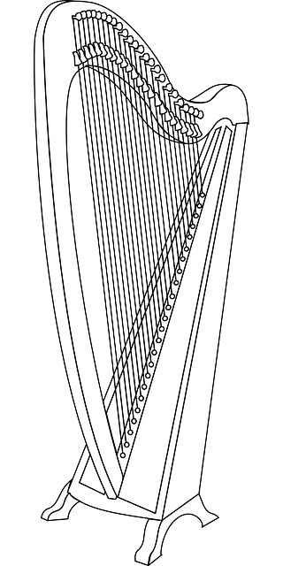
LEVERS
TUNING PIN

BASE
BODY or SOUNDBOX
PILLAR
STRINGS
SOUNDBOARD
NECK or HARMONIC CURVE

